Backend Technical Documentation
Oracle Basic Tutorials – Oracle APEX Application
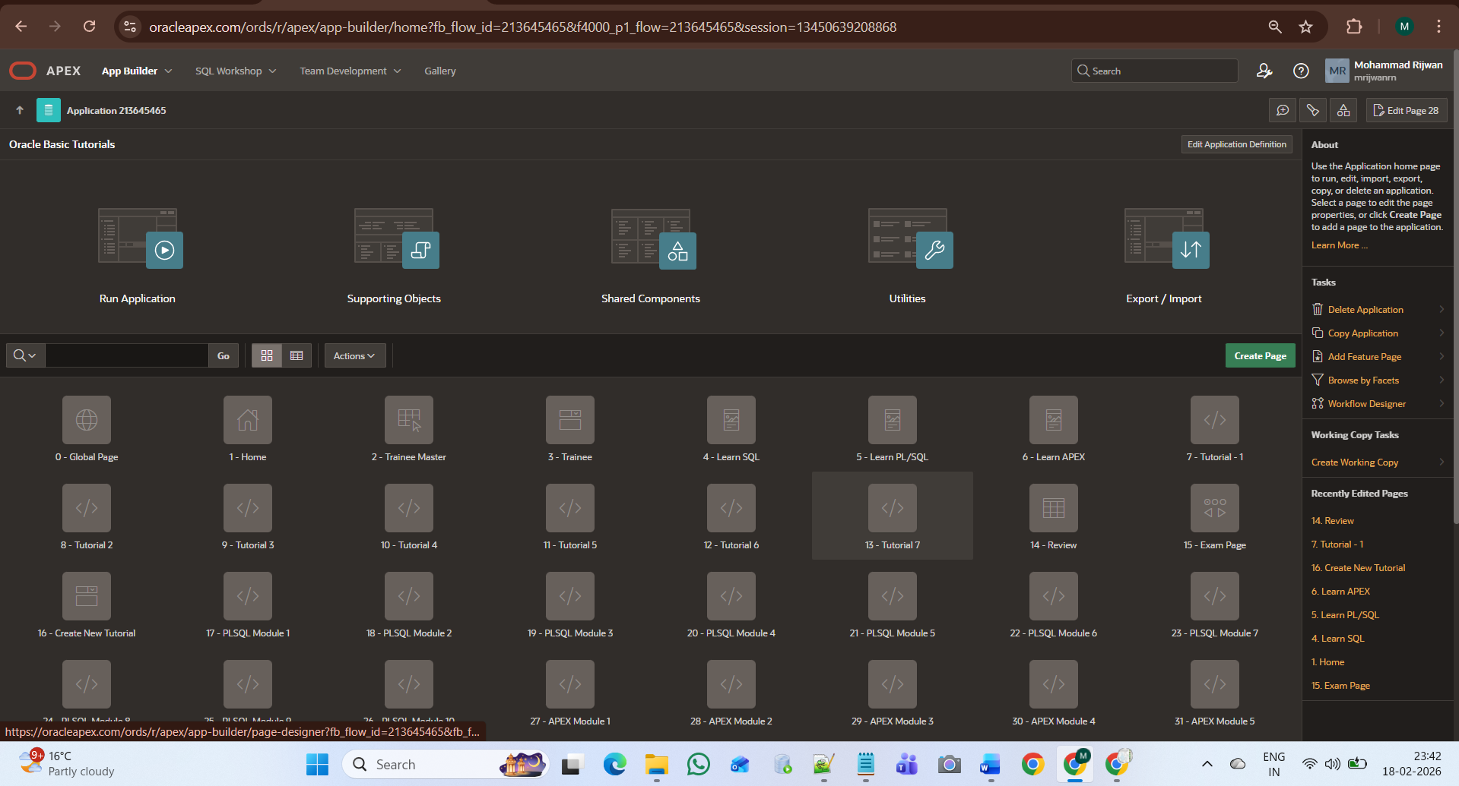
1. Application Overview (Backend Architecture)
The application Oracle Basic Tutorials is developed using Oracle APEX and follows a structured page-based architecture.
The backend consists of:
- Multiple Application Pages
- Dynamic SQL Queries
- Modal Dialog Forms
- Interactive Reports
- Drawer Pages
- Category-based Data Filtering
- Session State Management
- Dynamic Actions
- Database Tables & Constraints

2. Application Structure (Page-Level Architecture)
From the screenshot, the application includes the following key backend pages:
Core Pages
Page No | Page Name | Purpose
1 | Home | Dashboard with course cards
2 | Trainee Master | User management
3 | Trainee | Trainee data
4 | Learn SQL | SQL course listing
5 | Learn PL/SQL | PL/SQL course listing
6 | Learn APEX | APEX course listing
7–13 | Tutorial Pages | Detailed tutorial drawer pages
14 | Review | Test-based reporting
15 | Exam Page | Examination module
16 | Create New Tutorial | Modal dialog form
17–21 | PLSQL Modules | Module content pages
27–31 | APEX Modules | APEX detailed modules

3. Database Design (Logical Structure)
The backend is connected to database tables such as:
3.1 TUTORIALS Table
Stores all tutorial records.
Key Columns:
- TOPIC_ID (Primary Key)
- CATEGORY
- TOPIC_NO
- TITLE
- SUMMARY
- FULL_CONTENT
- CREATED_AT
- UPDATED_AT
3.2 REVIEW / TEST Table
Stores:
- Duration
- Test Rating
- Feedback
- Category
- Title
Used for the Review page reporting.
4. Navigation Logic (Backend)
4.1 Card-Based Navigation
- Home page cards use dynamic URLs.
- APEX_PAGE.GET_URL function generates secure navigation.
- Each card redirects to a category-specific page.
4.2 Sidebar Navigation
- Defined under Shared Components → Navigation Menu.
- Static links mapped to specific page numbers.
- Works globally across the application.
5. Tutorial Creation Process (Backend Flow)
When user clicks Add Tutorial:
- Modal Dialog Page (Page 16) opens.
- Category is auto-selected.
- Topic Number is auto-generated using:
SELECT NVL(MAX(TOPIC_NO),0) + 1
FROM TUTORIALS
WHERE CATEGORY = :P_CATEGORY;
- On Create:
  - Data is inserted into TUTORIALS table.
  - Session state validated.
  - Page refreshed.
  - New record appears dynamically.

6. Drawer Page Architecture
When user clicks any tutorial:
- Topic ID is passed via URL.
- Detail page loads dynamically.
- SQL query fetches FULL_CONTENT.
- Page displayed in Drawer mode (Dialog Template).
- No full page reloads.

7. Review Module Backend Logic
Page 14 – Review:
- Uses Interactive Report.
- Query joins tutorial & test tables.
- Supports:
  - Filtering
  - Searching
  - Sorting
  - Export
Used for performance analytics.
8. Security & Session Management
- Session State Protection enabled.
- Dynamic item protection handled.
- Hidden fields for secure inserts.
- Role-based navigation possible.
- APEX built-in authentication used.
9. Application Components Used
- Cards Region
- Interactive Report
- Modal Dialog Pages
- Drawer Pages
- Dynamic Actions
- SQL Queries
- PL/SQL Processing
- Shared Components
- Static Application Files
- Session State Protection
10. Version & Deployment
- Release Version: 1.0
- Platform: Oracle APEX
- Deployment Type: Web-based Application
- Supports PWA installation

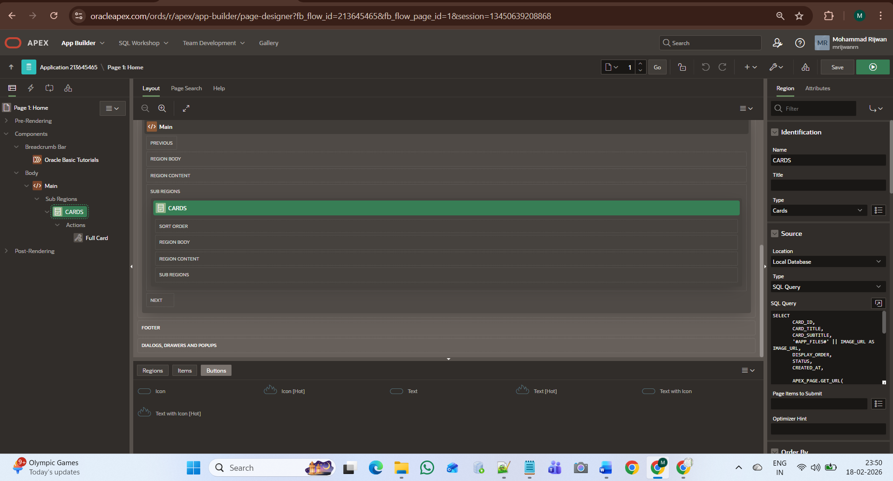

Page 1 Documentation
Page Name: Home
Page Number: 1
Page Type: Dashboard (Cards Based Navigation)

1. Purpose of Page
The Home page acts as the main dashboard of the Oracle Basic Tutorials application.
Its primary purpose is to:
- Display available courses visually
- Allow users to navigate to course modules
- Provide quick access to SQL, PL/SQL, APEX, and MCQ sections
- Serve as the starting point of the application

2. Main Component – Cards Region
Region Name:
CARDS
Region Type:
Cards
This region dynamically displays course categories in card format.

3. Data Source Configuration
Source Type:
SQL Query
Database:
Local Database
SQL Logic Used:
SELECT
CARD_ID,
CARD_TITLE,
CARD_SUBTITLE,
'#APP_FILES#' || IMAGE_URL AS IMAGE_URL,
DISPLAY_ORDER,
STATUS,
CREATED_AT,
APEX_PAGE.GET_URL(...) AS URL
FROM COURSE_CARDS
4. Database Table Used
Table Name:
COURSE_CARDS
Purpose:
Stores all dashboard card information.
Key Columns:
- CARD_ID (Primary Key)
- CARD_TITLE
- CARD_SUBTITLE
- IMAGE_URL
- DISPLAY_ORDER
- STATUS
- CREATED_AT

5. Card Rendering Logic
Each card displays:
- Image (fetched from Static Application Files)
- Title (Course Name)
- Subtitle (Description)
- Click Action (Redirect URL)

6. Navigation Logic
The navigation is handled using:
APEX_PAGE.GET_URL (p_page => ...)
This dynamically generates secure URLs to redirect users to:
- Learn SQL page
- Learn PL/SQL page
- Learn APEX page
- MCQ Practice page

7. UI Structure (Frontend Rendering)
Cards contain:
- Top Image Banner
- Title (Bold Heading)
- Subtitle Description
- Full Clickable Card Area
The card action is configured as:
Full Card Click Action
This ensures the entire card is clickable.

8. Order & Filtering
Cards are displayed based on:
- DISPLAY_ORDER (for sorting)
- STATUS = 'ACTIVE' (for visibility control)
Inactive cards are not shown.
9. Security Handling
- URLs generated securely using APEX_PAGE.GET_URL
- Session State Protection enabled
- Image files stored in Static Application Files
- Only active records are rendered

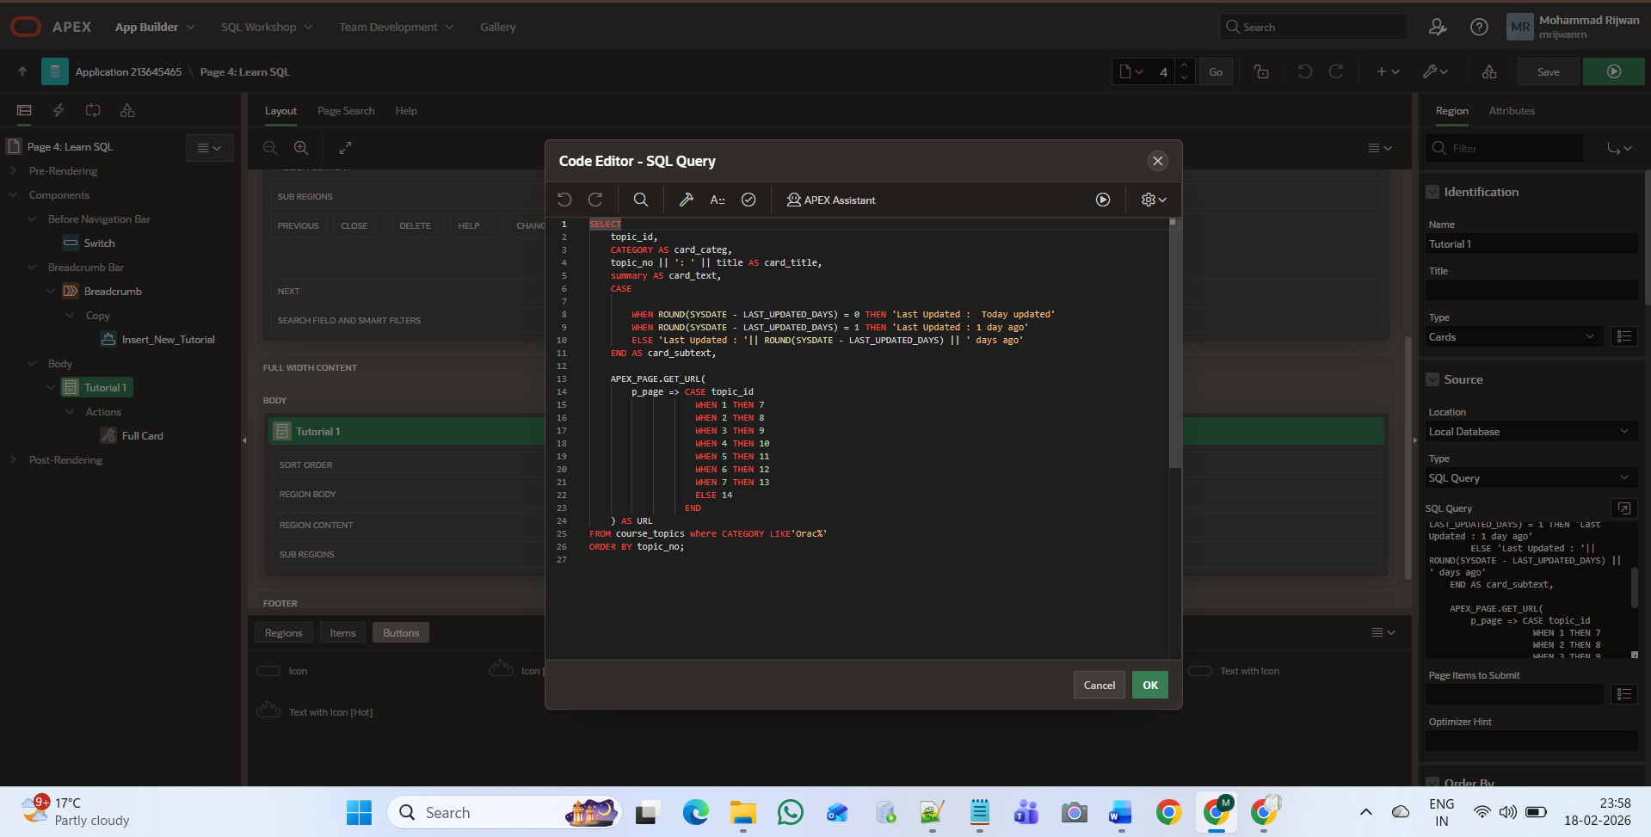

Page 4 – Learn SQL

1. Page Purpose
Page 4 (Learn SQL) displays all SQL course topics in card format.
Users can:
- View SQL topic list
- See title, summary, and last updated info
- Click any topic to open detailed tutorial (Drawer page)
- Add new SQL tutorial

2. Main Components
A. Switch Button (Before Navigation Bar)
- Button Name: Switch
- Location: Before Navigation Bar
- Purpose: Redirect user to Home page
- Used for quick navigation switching
B. Insert_New_Tutorial Button
- Located inside Breadcrumb region
- Action: Redirect to Page 16 (Create New Tutorial)
- Icon: fa-plus
- Purpose: Add new SQL tutorial

C. Tutorial Cards Region

Region Name: Tutorial 1
Type: Cards
Source Type: SQL Query
Displays SQL topics dynamically.

3. SQL Query Logic (Backend)

SELECT
topic_id,
CATEGORY AS card_categ,
topic_no || ' : ' || title AS card_title,
summary AS card_text,
CASE
WHEN ROUND(SYSDATE - LAST_UPDATED_DAYS) = 0 THEN 'Last Updated : Today updated'
WHEN ROUND(SYSDATE - LAST_UPDATED_DAYS) = 1 THEN 'Last Updated : 1 day ago'
ELSE 'Last Updated : ' || ROUND(SYSDATE - LAST_UPDATED_DAYS) || ' days ago'
END AS card_subtext,
APEX_PAGE.GET_URL(...) AS URL
FROM course_topics
WHERE CATEGORY LIKE 'Oracle SQL'
ORDER BY topic_no;

4 Database Table Used
Table: COURSE_TOPICS
Important Columns:
- TOPIC_ID
- CATEGORY
- TOPIC_NO
- TITLE
- SUMMARY
- LAST_UPDATED_DAYS

5 Navigation Logic
When user clicks any card:
- APEX_PAGE.GET_URL generates secure link
- Redirects to:
  - Page 7
  - Page 8
  - Page 9
  - Page 10
  - etc. (Based on topic_id)
Each topic opens in:
- Drawer Page
Shows full detailed content

6. Card Display Structure
Each card shows:
- Topic Number + Title
- Category (Oracle SQL)
- Summary
- Last Updated Status
- Full Clickable Card

7. Dynamic Features Used
- APEX Cards Region
- APEX_PAGE.GET_URL
- CASE statement for dynamic updated text
- Redirect button
- Drawer Page Mode
- Database driven rendering

8. Security
- URLs generated using APEX_PAGE.GET_URL
- Session state protection
- Only SQL category filtered using WHERE clause
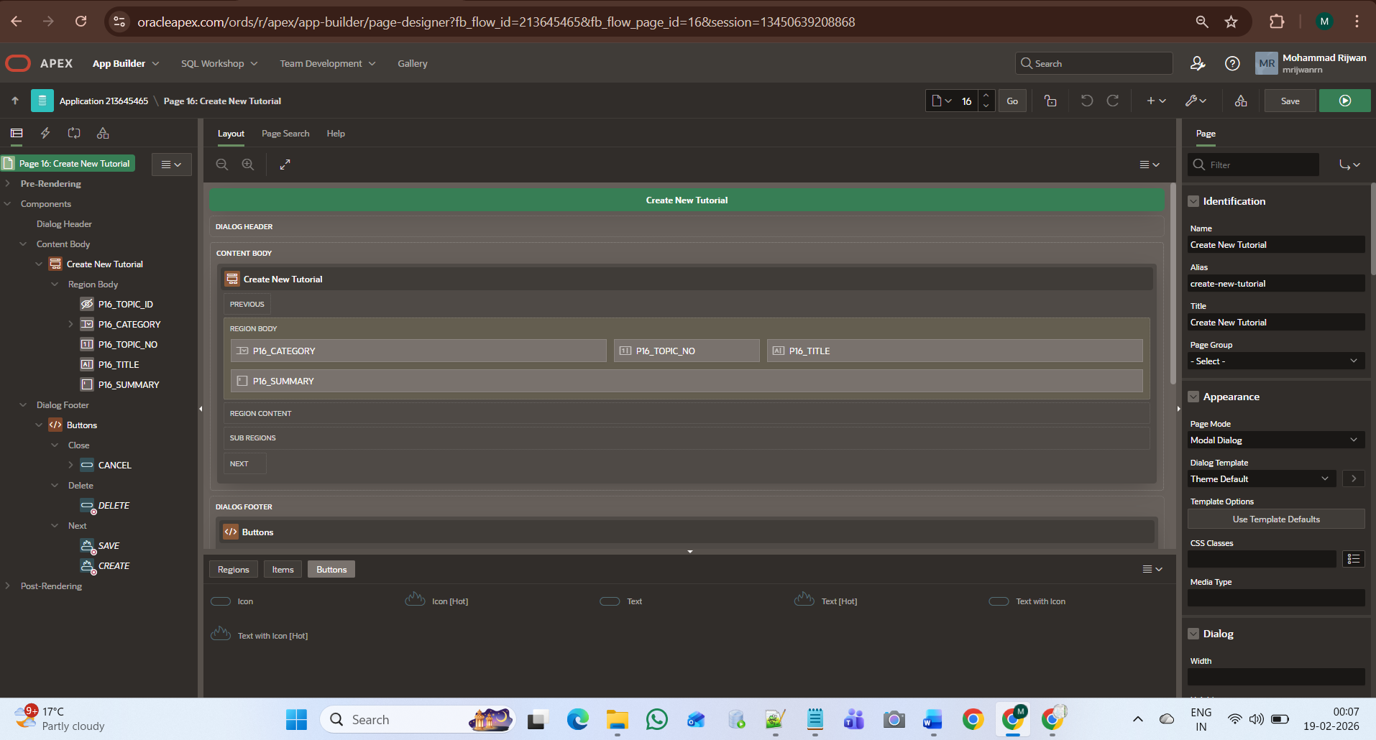

Page 16 – Create New Tutorial
1. Page Information
- Page Number: 16
- Page Name: Create New Tutorial
- Page Mode: Modal Dialog
- Purpose: Insert new tutorial record into database
This page opens as a popup dialog from Learn SQL / Learn PL/SQL / Learn APEX pages.

2. Page Purpose
This page allows admin/user to:
- Select Category
- Auto-generate Topic Number
- Enter Title
- Enter Summary
- Save tutorial into database
After clicking Create, the new tutorial appears automatically in the respective course page.

3. Page Items (Form Fields)
Item Name | Purpose
P16_TOPIC_ID | Primary Key (Hidden / Auto Generated)
P16_CATEGORY | Selected Course Category
P16_TOPIC_NO | Auto Generated Topic Number
P16_TITLE | Tutorial Title
P16_SUMMARY | Tutorial Description

4. Topic Number Auto Logic
When user selects Category:
- System fetches:
SELECT NVL(MAX(topic_no),0)+1
FROM course_topics
WHERE category = :P16_CATEGORY;
- Automatically sets next topic number.
This ensures:
- No duplicate topic numbers
- Proper ordering
- Category-wise numbering

5 Buttons in Dialog Footer
🔹 CANCEL
- Closes dialog
- No data saved
🔹 CREATE
- Inserts new record into COURSE_TOPICS
- Redirects back to course page
- Refreshes topic list

6. Database Interaction
Table Used:
COURSE_TOPICS
Insert Operation:
INSERT INTO COURSE_TOPICS
(
topic_id,
category,
topic_no,
title,
summary,
last_updated_days
)
VALUES
(
course_topics_seq.NEXTVAL,
:P16_CATEGORY,
:P16_TOPIC_NO,
:P16_TITLE,
:P16_SUMMARY,
SYSDATE
);

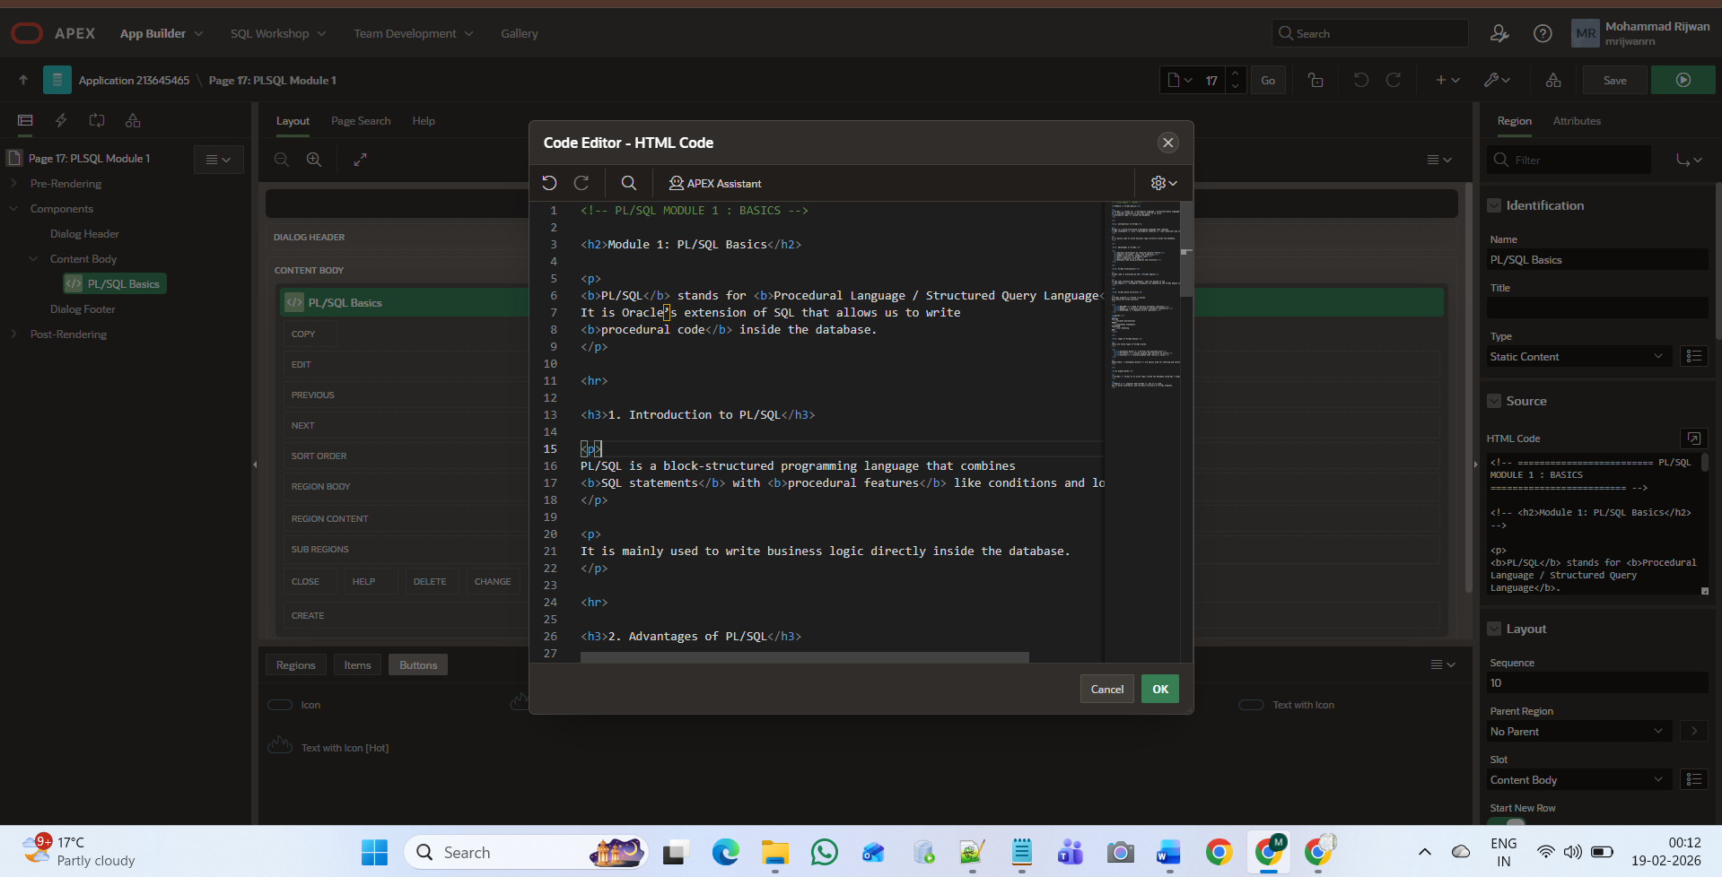

Page 17 – PL/SQL Module 1 (Detail Drawer Page)

1. Page Information
- Page Number: 17
- Page Name: PL/SQL Module 1
- Page Type: Drawer / Detail Page
- Region Type: Static Content
- Content Source: HTML Code

2. Purpose of Page
This page displays the detailed tutorial content of a selected PL/SQL topic.
It opens when a user clicks a PL/SQL topic card from:
Learn PL/SQL Page

3. Content Structure
The region uses:
Static Content (HTML)
Content is written manually in HTML format inside APEX.

